Phase 7: Implement Client Script & UI Policy (Incident)
Project Documentation Phase
1. Introduction
The Project Documentation Phase describes the complete implementation of the Implement Client Script & UI Policy (Incident) micro project in ServiceNow. It provides a structured record of the project objectives, requirements, development activities, configuration details, testing procedures, and final outcomes.
The documentation is prepared to explain how UI Policies and Client Scripts work together to enforce data integrity, automate field updates, control field behavior, and validate Incident records before submission. It also serves as a reference for future maintenance, troubleshooting, and further development.
2. Project Overview
The project focuses on improving the quality and consistency of Incident records through client-side controls. It uses a UI Policy to apply conditional field behavior and three types of Client Scripts to automate and validate user interactions.
Project details
Item | Description
Project name | Implement Client Script & UI Policy (Incident)
Platform | ServiceNow
Application | Incident Management
Main features | UI Policies, UI Policy Actions, Client Scripts
Script types | onChange, onSubmit, onCellEdit
Purpose | Improve Incident data integrity and form usability
3. Project Objectives
The main objectives documented for this project are:
- To implement conditional field behavior on Incident forms.
- To make Assignment Group mandatory when Impact is High.
- To make Urgency read-only when Impact is High.
- To automatically set Urgency to High when Impact changes to High.
- To prevent submission of High Impact Incidents when Assigned To is empty.
- To block direct State changes through list editing.
- To verify that users can still update State through the Incident form.
4. System Requirements
The project requires a ServiceNow instance with access to the Incident table and configuration modules.
Requirement | Purpose
ServiceNow instance | Environment for configuration and testing
Administrative/configuration access | Create and modify UI Policies and Client Scripts
Incident table | Target table for the project
UI Policies module | Create conditional field behavior
UI Policy Actions | Configure field properties
Client Scripts module | Implement client-side logic
Incident forms and lists | Execute functional tests
5. System Design and Configuration
The project is designed around a single condition: Impact is High. When this condition is true, the UI Policy and related actions apply the specified controls. Client Scripts handle automatic field updates, submission validation, and list-edit restrictions.
Configuration workflow
Incident form
User creates or updates an Incident
Impact = High
Condition checked by the UI Policy and onChange script
UI Policy
- Assignment Group mandatory
- Urgency read-only
Reverse if false enabled
onChange Client Script
- Set Urgency to High
- Display information message
Save and list interactions
onSubmit validates Assigned To; onCellEdit blocks State list editing.
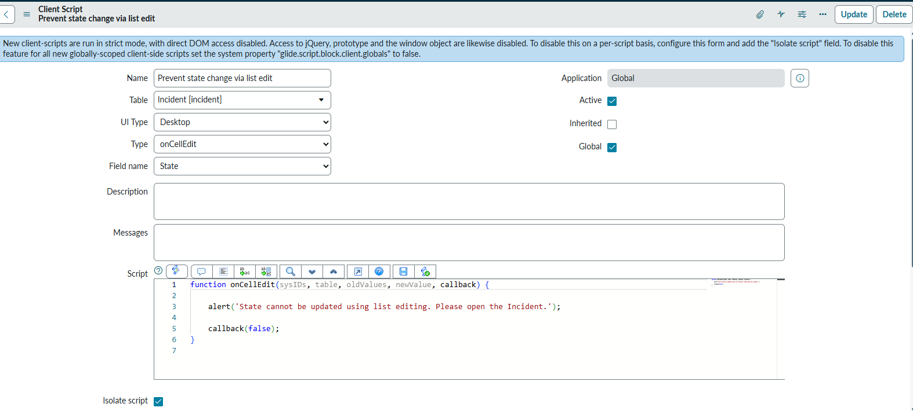

6. Module Documentation
6.1 UI Policy – High Impact Control
The UI Policy is created on the Incident table with the name High Impact Control. Its condition is Impact is 1 – High, and Reverse if false is enabled.
Its associated UI Policy Actions configure the following fields:
- Assignment Group: Mandatory is enabled so the user must provide a group when the policy condition is true.
- Urgency: Read-only is enabled so the field remains visible but cannot be manually changed while the condition is true.
When Impact is no longer High, the policy reverses these field changes.
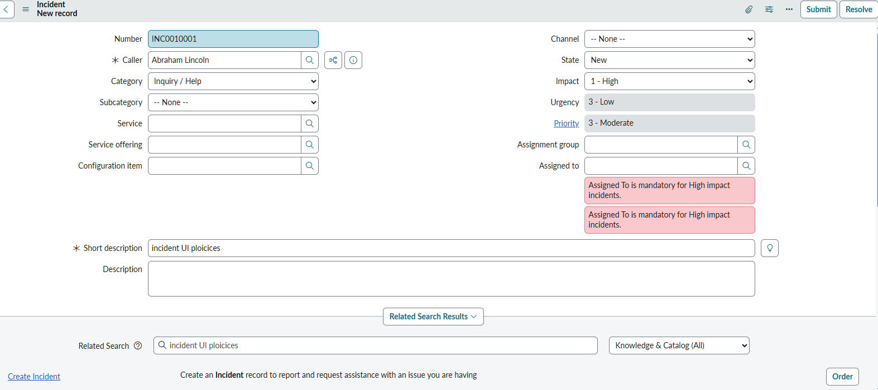
6.2 onChange Client Script – Auto Set Urgency
This Client Script runs when the Impact field changes. It checks whether the form is loading or the new value is empty. If neither condition applies and Impact is High, it sets Urgency to High and displays an informational message.
function onChange(control, oldValue, newValue, isLoading) {
if (isLoading || newValue == '') {
return;
}

if (newValue == '1') {
g_form.setValue('urgency', '1');
g_form.addInfoMessage(
'Urgency set to High for High impact incident.'
);
}
}
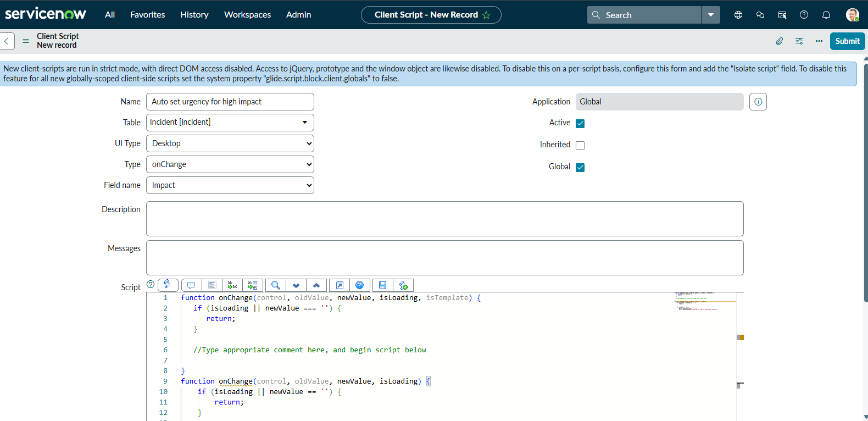
6.3 onSubmit Client Script – Save Validation
This Client Script executes when the user submits an Incident form. It checks whether Impact is High and Assigned To is empty. If both conditions are true, it displays an error and returns false to prevent submission. Otherwise, it returns true.
function onSubmit() {
if (g_form.getValue('impact') == '1' &&
g_form.getValue('assigned_to') == '') {

g_form.showErrorBox(
'assigned_to',
'Assigned To is mandatory for High impact incidents.'
);
return false;
}

return true;
}
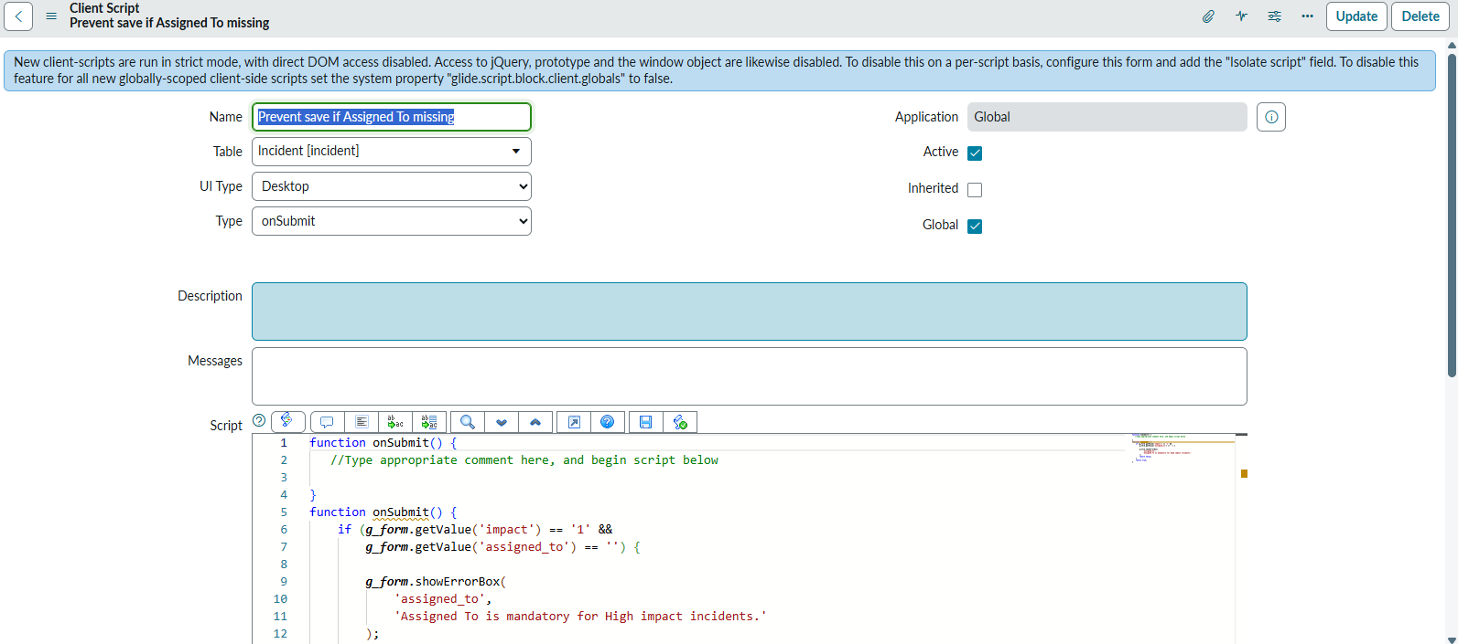
6.4 onCellEdit Client Script – Prevent State List Editing
This Client Script runs when the State field is edited directly in the Incident list. It displays an alert and calls callback(false) to reject the list edit.
function onCellEdit(sysIDs, table, oldValues,
newValue, callback) {
alert(
'State cannot be updated using list editing. Please open the Incident.'
);

callback(false);
}
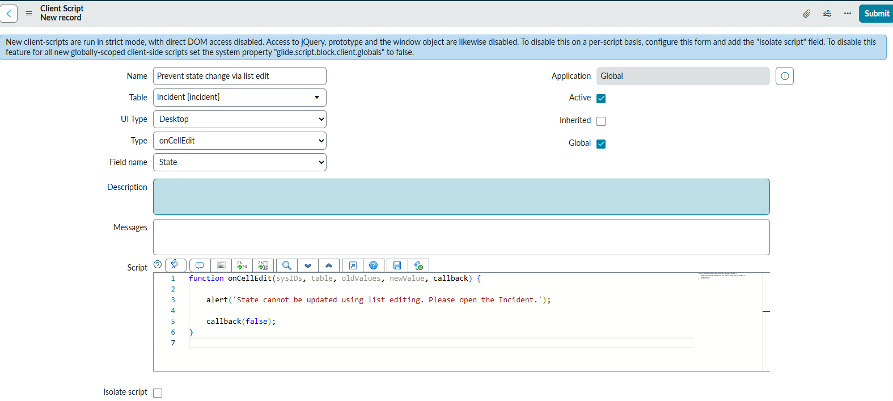
7. Implementation Procedure
The project implementation is documented in the following order:
- Create the High Impact Control UI Policy on the Incident table.
- Set the condition to Impact is High and enable Reverse if false.
- Create the Assignment Group UI Policy Action and enable Mandatory.
- Create the Urgency UI Policy Action and enable Read-only.
- Create the onChange Client Script for the Impact field.
- Create the onSubmit Client Script to validate Assigned To.
- Create the onCellEdit Client Script for the State field.
- Save the configurations and test them using Incident forms and lists.
This order establishes the condition and field behavior first, then adds automation and validation.
8. Testing Documentation
The testing documentation records the functional tests used to verify the project. Each test should include the test case, procedure, expected result, actual result, and status.
Test case | Expected result
High Impact mandatory validation | Submission blocked when Assigned To is empty
Successful submission | Incident saves when validation requirements are satisfied
UI Policy activation | Assignment Group becomes mandatory
Urgency read-only | Urgency cannot be manually edited for High Impact
Automatic Urgency update | Urgency is set to High when Impact changes to High
Reverse condition | Policy field changes are reversed when Impact is not High
List edit blocking | State list edit is rejected
Form-based update | State can be updated through the Incident form
Test execution record: Actual results and Pass/Fail status should be filled in after executing each test in the ServiceNow instance. Screenshots of the configured records, messages, and field behavior can be attached as evidence.
9. User Instructions
The following instructions describe how a user should interact with the configured Incident form:
- Open the Incident form to create or update a record.
- Select the appropriate Impact value.
- When Impact is High, provide the required Assignment Group and Assigned To information.
- Review the Urgency field, which is automatically set to High by the onChange script and made read-only by the UI Policy.
- Submit the Incident after completing the required information.
- To change State, open the Incident form instead of editing the State field directly in the list.
10. Maintenance and Troubleshooting
The configuration should be reviewed if the expected behavior does not occur.
Issue | Configuration to check
Assignment Group is not mandatory | UI Policy condition and Assignment Group UI Policy Action
Urgency is not read-only | Urgency UI Policy Action and Reverse if false
Urgency is not automatically set | onChange type, Impact field, script, and internal value
Incident saves without Assigned To | onSubmit script activation and assigned_to field name
State can be changed through list editing | onCellEdit type, State field selection, and script
Field behavior does not reverse | UI Policy Reverse if false setting
Changes to the configuration should be tested after implementation to ensure that the original behavior remains correct.
11. Project Deliverables
The documentation phase identifies the following project deliverables:
- Configured High Impact Control UI Policy.
- Assignment Group and Urgency UI Policy Actions.
- onChange Client Script for automatic Urgency assignment.
- onSubmit Client Script for Assigned To validation.
- onCellEdit Client Script for State list-edit restriction.
- Functional testing checklist and execution record.
- Screenshots showing configuration and test evidence.
- Final project report describing the implementation and outcomes.
12. Limitations
The project uses client-side controls to manage form behavior and validation. Its checks are intended for the ServiceNow user interface and do not, by themselves, establish server-side enforcement for every possible way records could be changed.
The project also applies two separate rules to different fields: the UI Policy makes Assignment Group mandatory, while the onSubmit Client Script checks Assigned To. Both behaviors must be maintained and tested independently.
13. Conclusion
The Project Documentation Phase provides a complete written record of the Implement Client Script & UI Policy (Incident) micro project. It describes the project objectives, system requirements, design, configuration, implementation procedures, testing approach, user instructions, and maintenance guidance.
The project demonstrates how ServiceNow UI Policies and Client Scripts can work together to control Incident form behavior, automate field updates, validate required information, and restrict list editing. The documentation supports understanding, verification, and future maintenance of the implemented solution.

